**Alon Bar**

**201639663**

**PART A**

1. Implemented
2. Some results using quiver:

K = 4 Sigma = 3 region = 15 resize = 1

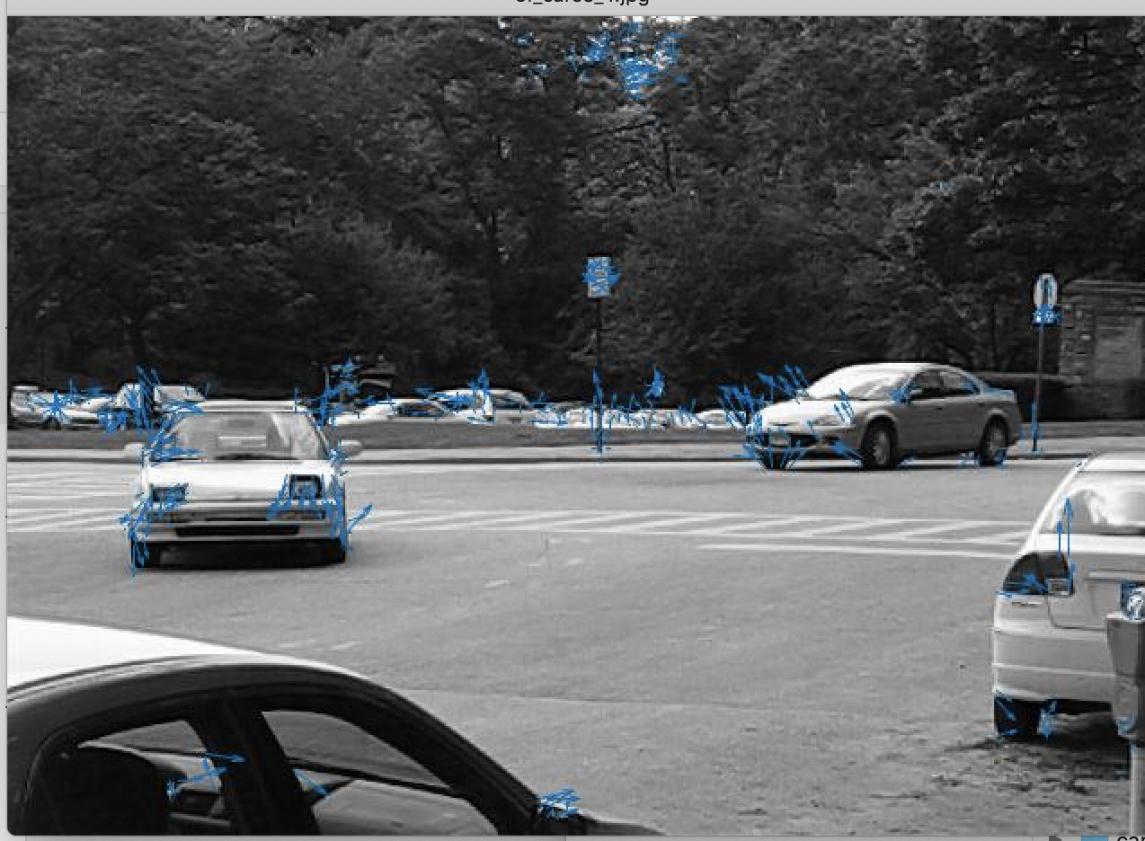

K = 4, Sigma = 3, regions = 6, resize = 0.5:

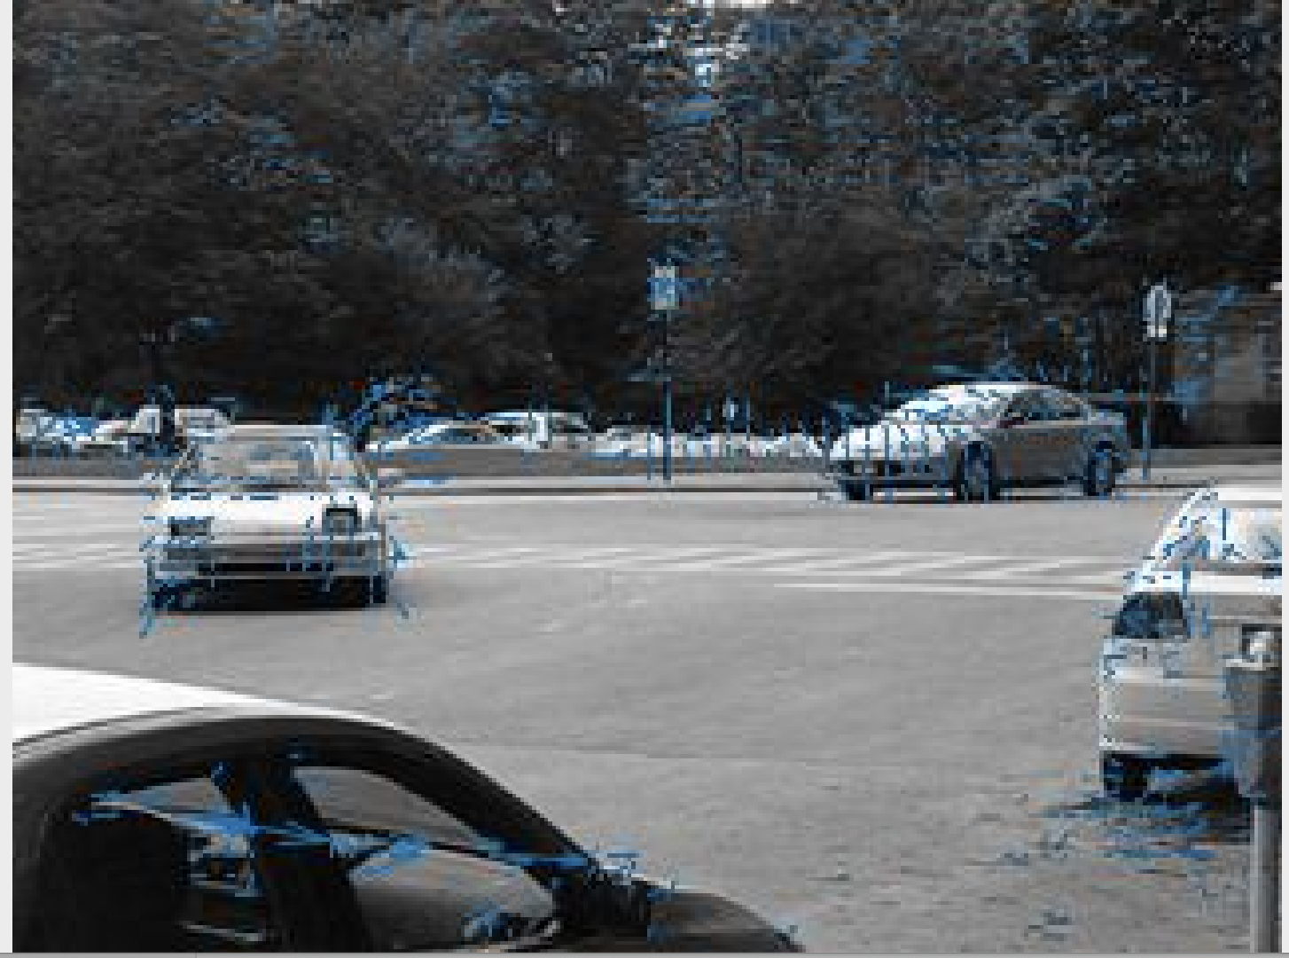

K = 10, sigma = 3, region = 4, resize = 0.5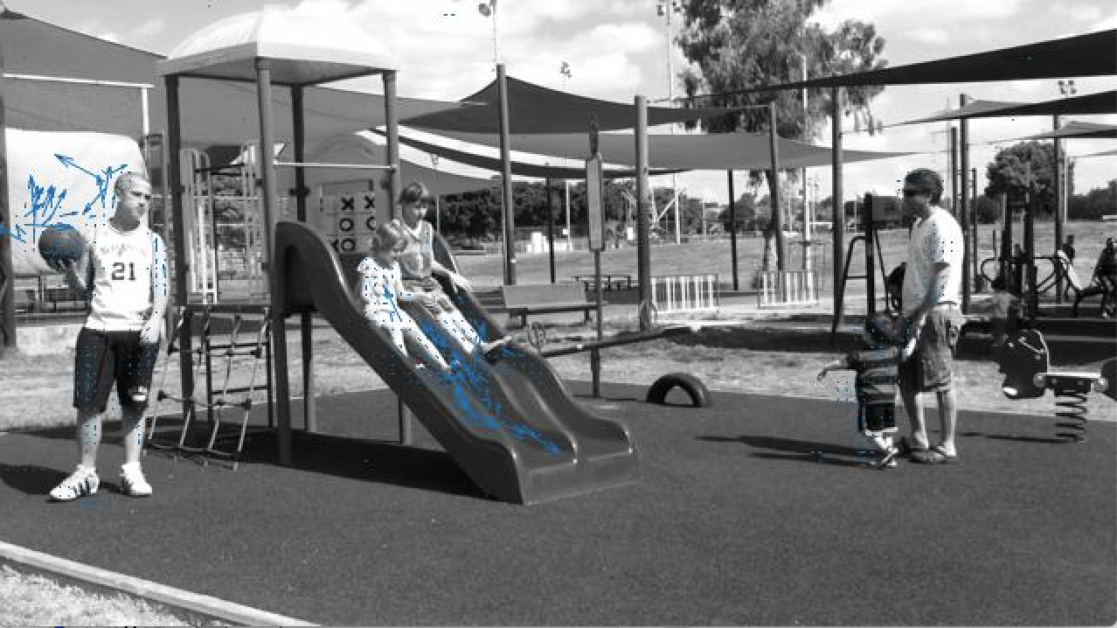

Questions 3-5, I demonstrate how I generated these images in run3.m script.

let us observe at the way the parameters affect the OF.

Let us change one parameter at a time and try to explain the difference in results.

I added another parameter to OF which is the minimum eigenvalue I permit in order to calculate the OF a pixel. This was giving much better results than calculating the rank of C.

In every sequence I gave a different eigenvalue.

K = 2, sigma =1 region = 4.

So we are starting with small jumps between the frames, giving each pixel the highest values (by setting sigma 1 ) and giving some small weight to its almost immediate neighbours.

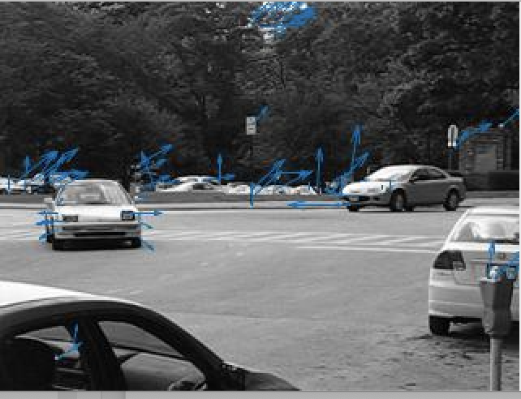

Now lets increase the sigma on the same frame

K = 2, sigma =3 region = 4 resize = 0.5:

The results Didn’t change to much, even go a bit worst, we can see that increasing the sigma with this region size introduced some noize that previously we did not see like the arrow at the front of the upper right car, or the noise at the middle of the picture with the trees.

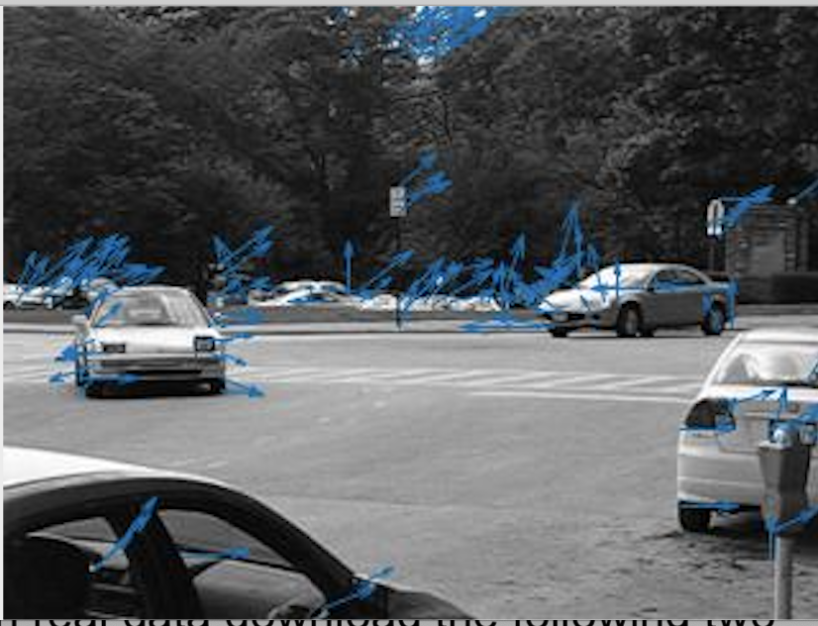

We can also see a lot of noise from the cars at the other side of the street which are not even moving !

Only the camera is moving and one car at the background.

Lets keep these parameters and change k

K = 4. Sigma = 1, region = 4 resize = 0.5

It seems like the movement of the cars is a bit confusing now, with 4 frames and regions 1, On the other hand the cars on the other side have much less movement and the only cars that is actually moving has an arrow.

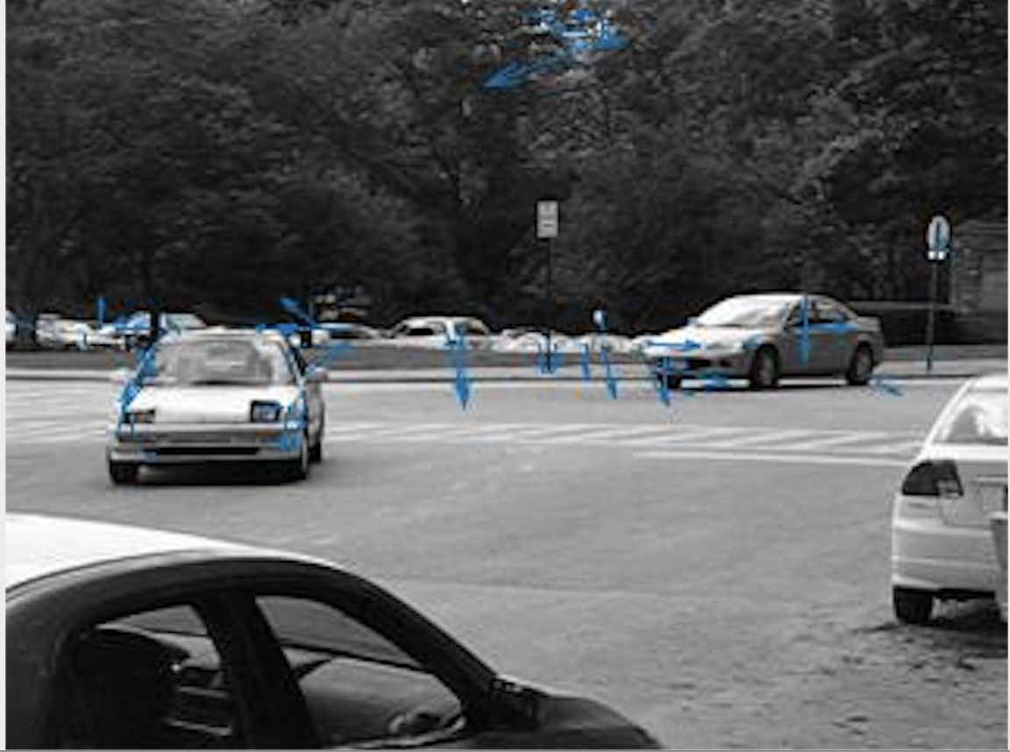

K = 4. Sigma = 3, region = 4 resize = 0.5

We are now experiencing much less movement from the background which reflect the change between frames much better.

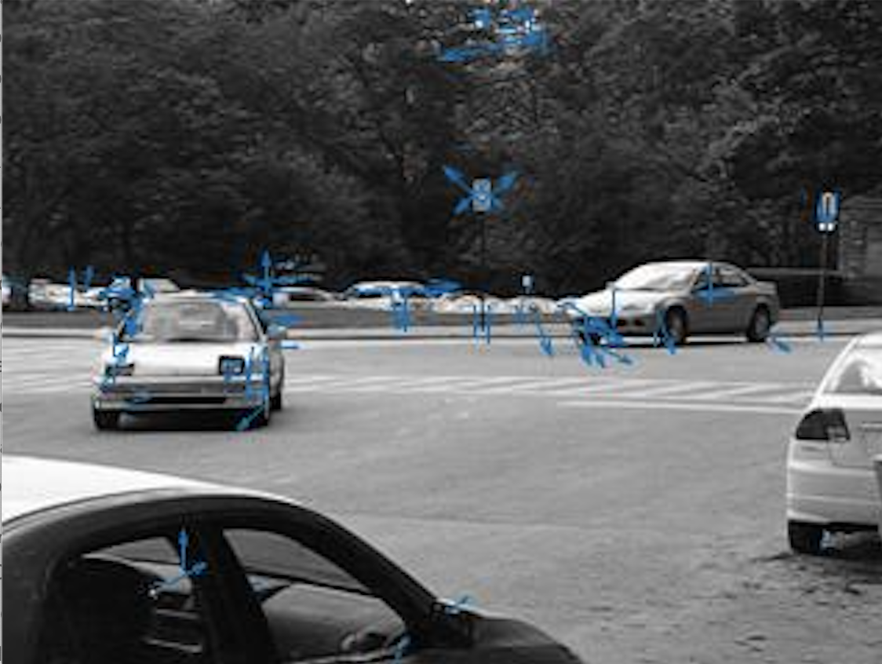

Lets increase the region size, and then the sigma size and see whether we can capture the movement of the cars with k =4

K = 4. Sigma = 3, region = 10 resize = 0.5

So now, with k=4 we can see the actual movement of the cars much better. This can be explained because the movement between two frames with difference of 4 was too big for a region of 4 pixels to capture

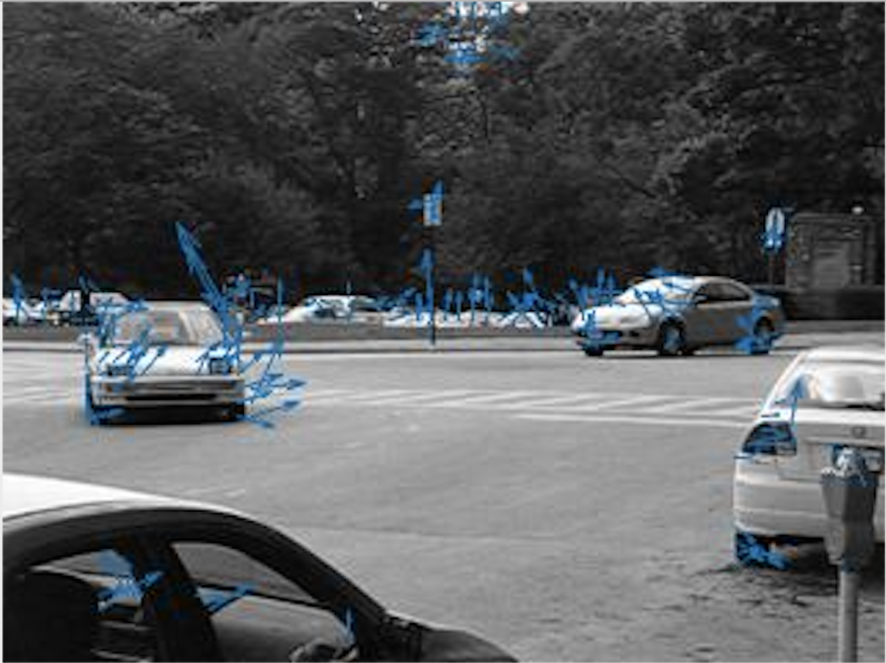

Lets increase the sigma:

K = 4. Sigma = 7, region = 10 resize = 0.5

We can now see that we are still capturing the movement of the car in sort of similar way, but we decreased some of the noise in the middle upper trees.

This can be explained because with a bigger sigma, we are giving the neighbours more weight. So for an actual movement to be detected the who area needs to be moving together in a more substantial way, like a moving object ( moving car) .

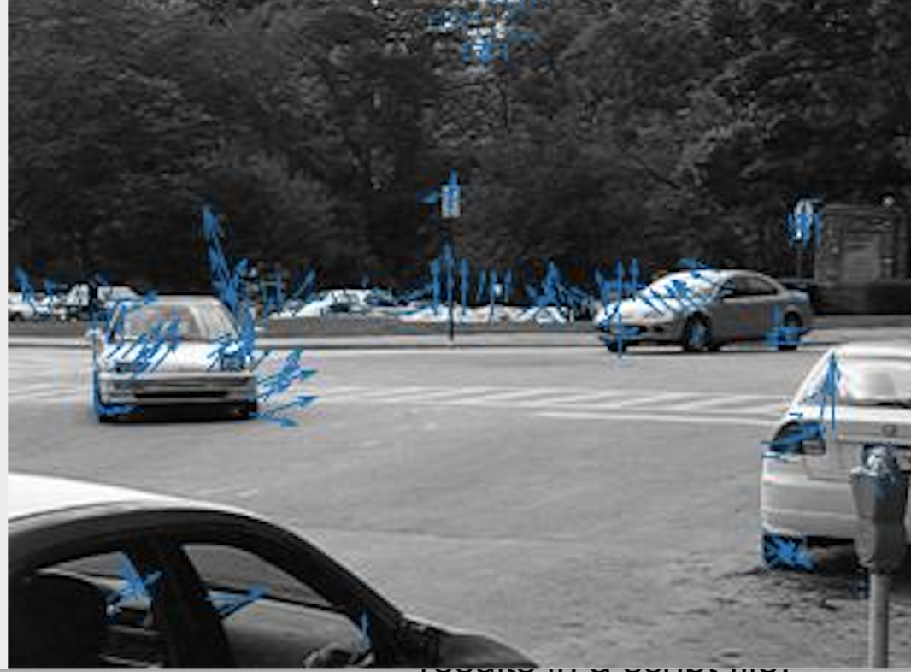

Lets increase the region even more

K = 4. Sigma = 7, region = 20 resize = 0.5

So now the movement of each car is event much more evident and the arrows seems to agree in a direction much more. Again This is happening because we affiliate a movement to a bigger area, so movements has to be rigid

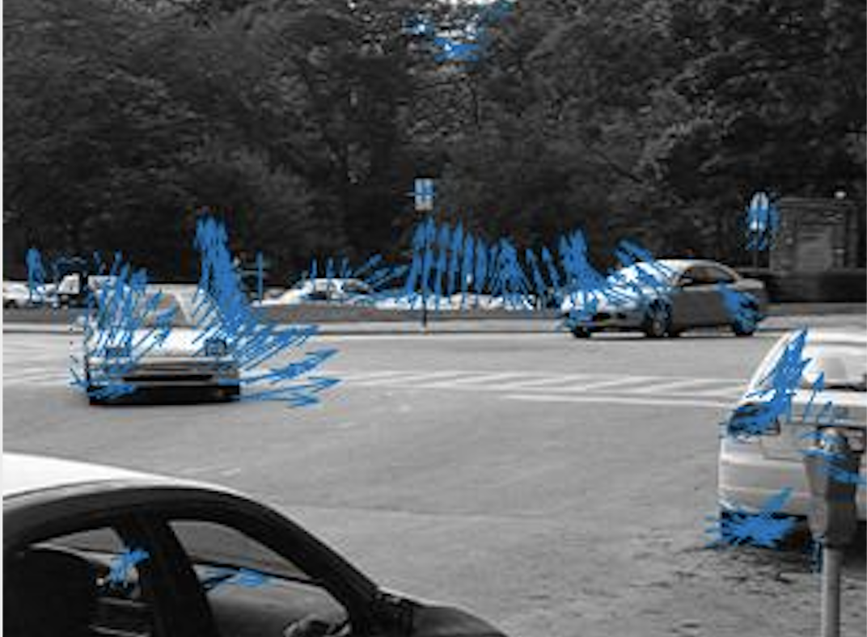

K = 2. Sigma = 7, region = 20

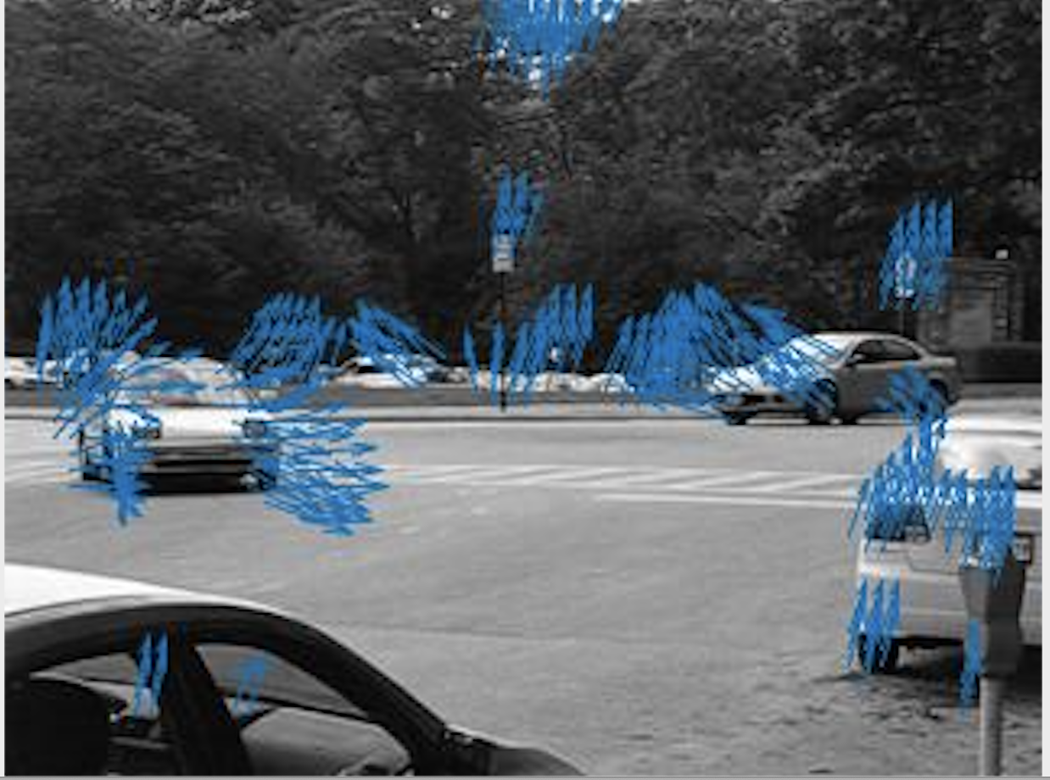

Let us notice that if the sigma would now drop to 1

K = 4. Sigma = 1, region = 20 resize = 0.5

The optical flow would be “confused”

Because the change is to big to be concluded by a high weight per pixel, even we we increase the region to 20, the distribution in the gaussian function we grant too much weight to the pixel itself and all the far neighbours would be set to 0, which is just equivalent to having a smaller region

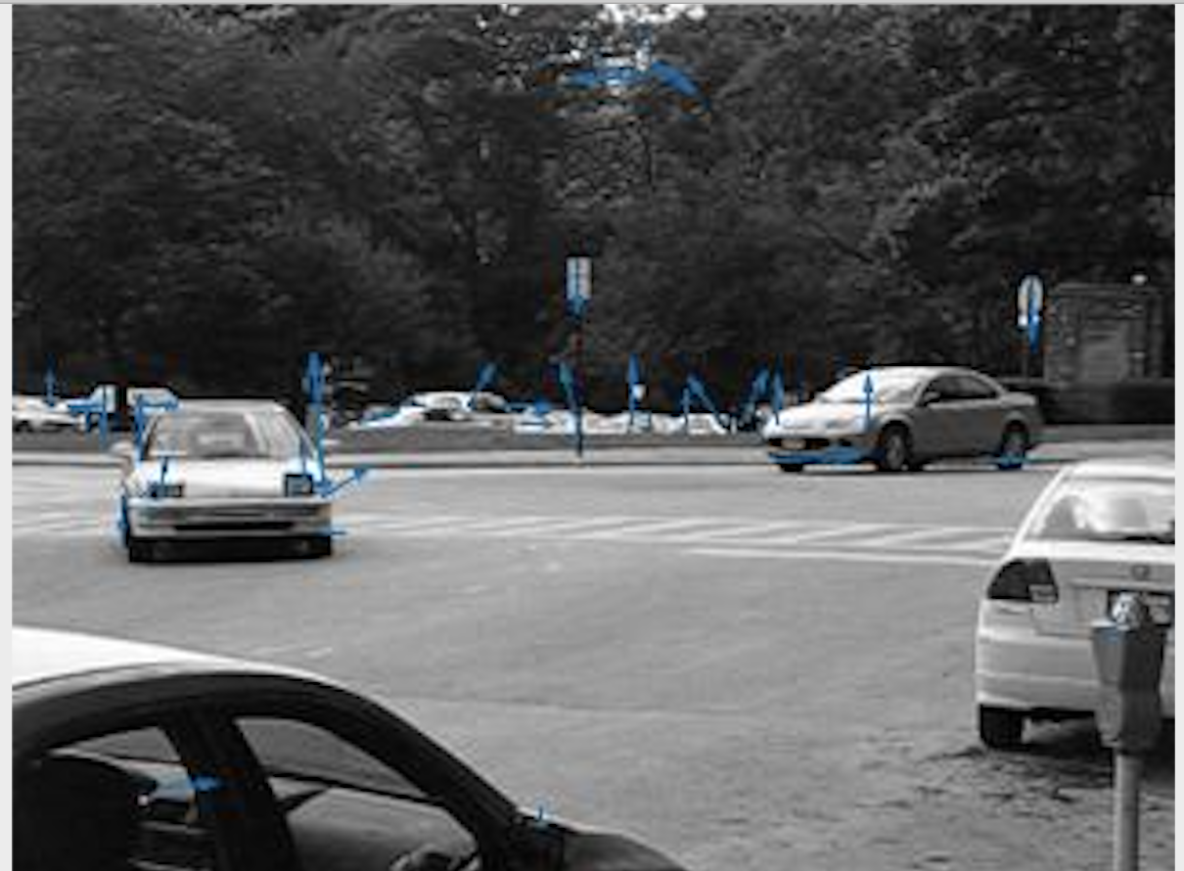

Lets analyse the SLIDES video .

I’m running it on mac and had to convert the video to mp4 because I had problems with the avi file.

K = 4. Sigma = 1, region = 15 resize = 0.5:

With these parameters a lot of the movements are not captured. For example the father and child movements are clearly not caught.

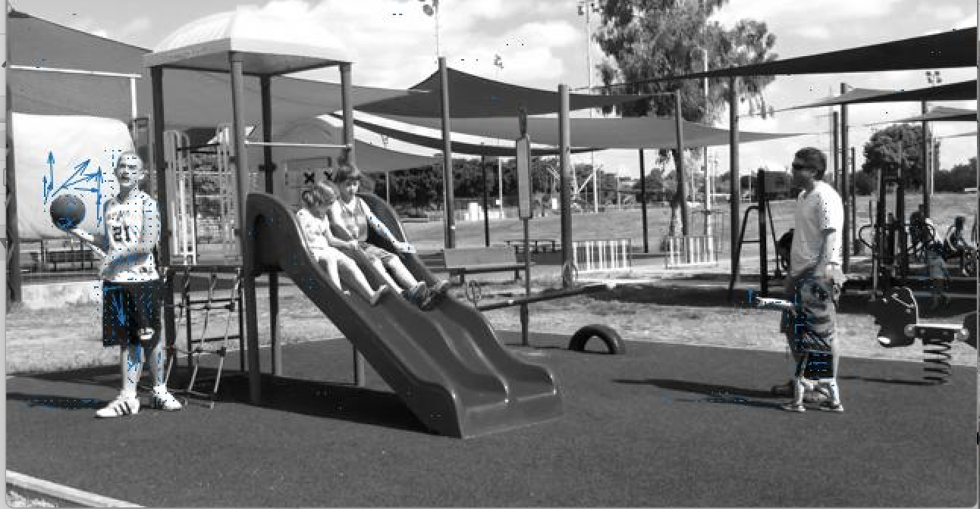

For similar purposes as before once I increase the sigma

K = 4. Sigma = 10, region = 15 resize = 0.5:

The movements of the child's and the father are now captured but not very clear, but now much noise is in, for example the kid with the basketball is obviously moving but its not clear where. In the movie we can see a lot of rotation in his movements whih might explained why its a bit hard to capture it with optical flow.

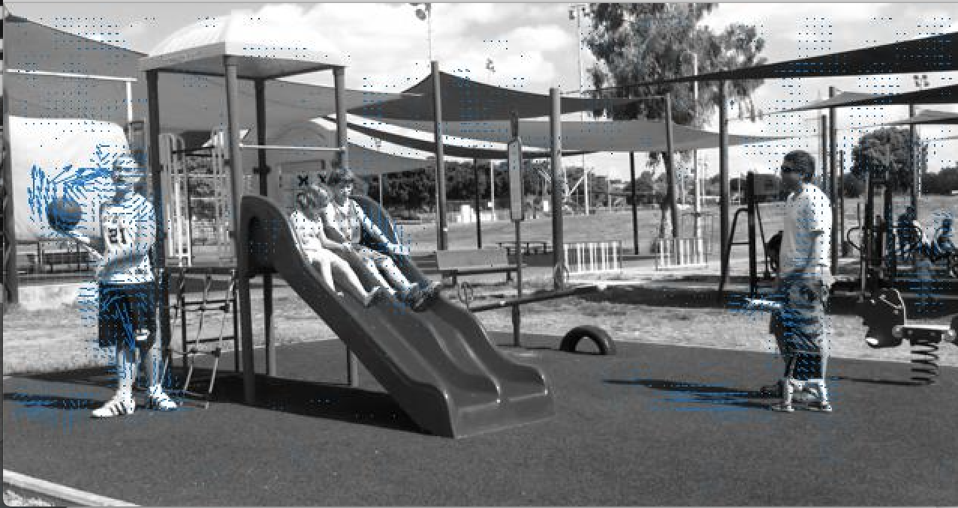

In the car sequence the movements were much more rapid, lets increase the k by a lot.

K = 10, sigma = 3, region = 15 resize = 0.5.

We can now clearly see the girl that are on the sliding going down with very little noise in the background.

I was not able to get such a result with smaller frame jumps without adding so much noise in the background. This is clearly because the change in temporal domain allowed us to catch this change

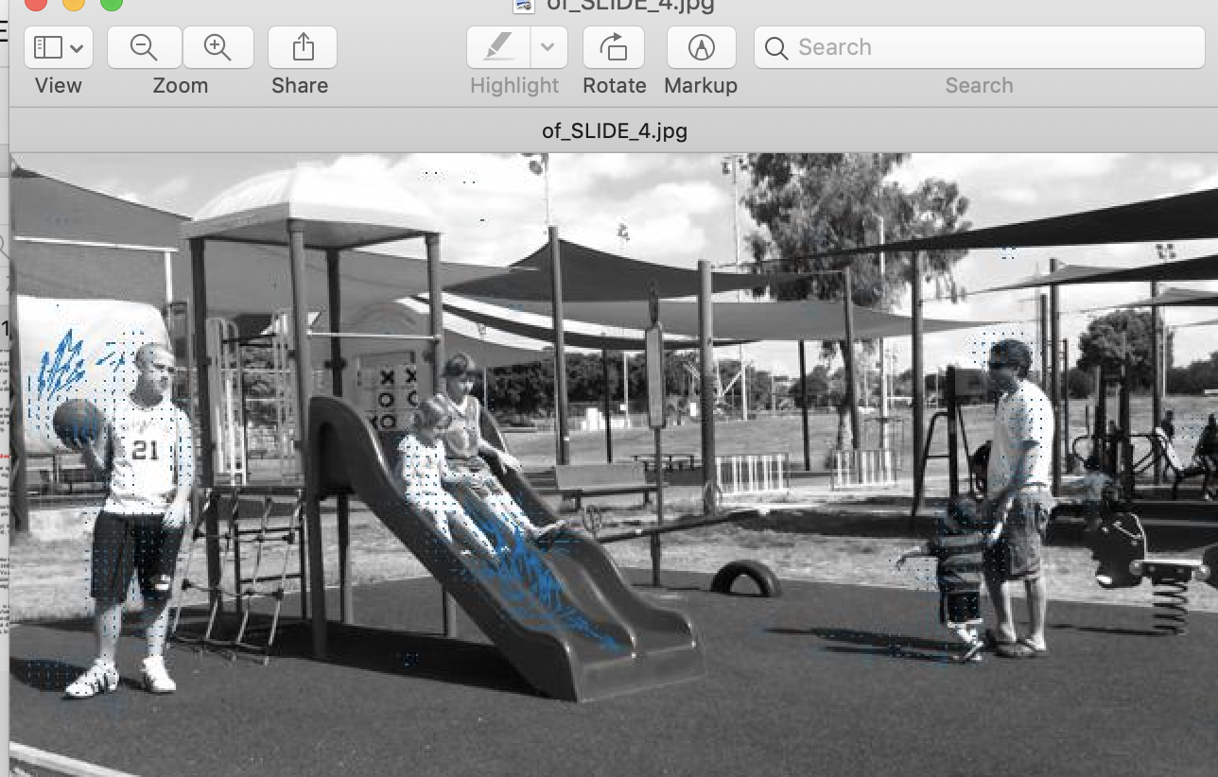

For Conclusion I noticed that its very hard to get the expected results…

But more importantly the parameters are tightly coupled and we need to take into consideration the way they affect each other .

1. In order to get the change in rigid objects, having a larger region would really help, especially when the camera moves a lot .
2. Larger region allows larger sigma, which many times would reduce the noise.
3. Increasing sigma really helps getting rid of noise.
4. Finding the the right threshold for the eignvalue is important in order to calculate OF only for real moving pixels and not noise
5. Larger region size affects the time performance of the algorithm.

**Question 6**

When using imwarp using the horizontal and vertical vectors we received we are trying to project frame1 -> frame2 according to the optical flow.

When the jump between frames is not too ambitious we are expecting to have some success at least between some of the frames.

Lets observe at imwarp of images we’ve seen above.

K = 2, sigma = 7, region = 15

Imshowpair before projection:

Difference of pixels:

511932

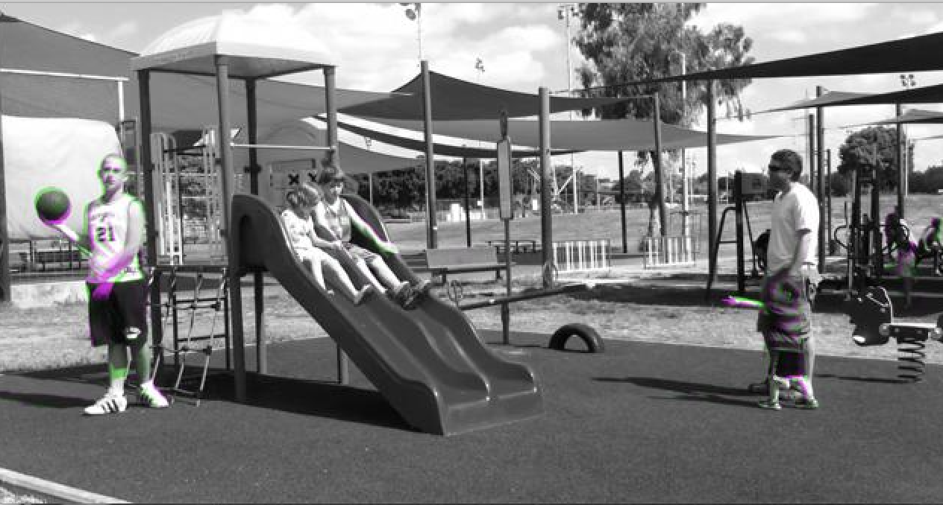

After projection:

Difference of pixels:

503281

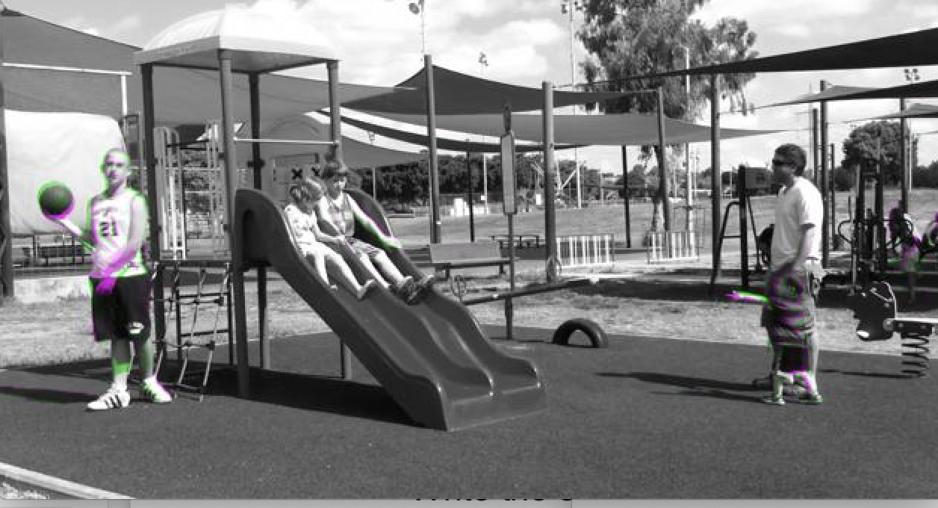

So the difference is slightly better between the two images.

Lets increase K and remain with the same parameters

K = 10

Pixels difference :

1291867

Before imwarp

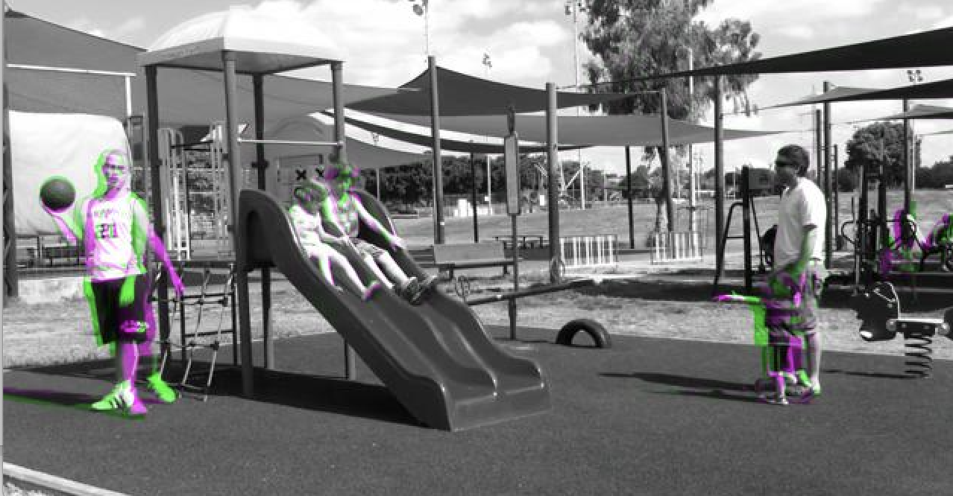

After imwarp

1464637

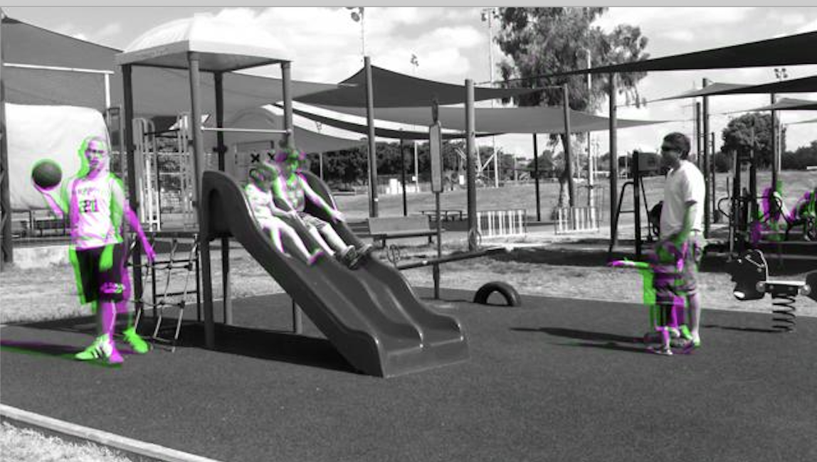

So with this amount of change in frames it only became a worse projection .

Unfortunately I couldn’t find a way to make the imwarp work much better than I just showed…

**Question 7-8**

So Far we ran the algorithm on images resized to 0.5

Which means everything was closer by about 50% but about 50% of the info is lost as well.

Which means that for the same parameters the optical flow for “the same” pixel (the pixels are different), but let’s say that for the same corner will be twice stronger.

On the other hand, with a fixed region size, for large motions, as in big change between two consecutive frame we will need to resize the image in order to capture the optical flow correctly

For example lets look at

K = 2, sigma = 7 , region = 20.

Left original, right resize 0.5

We can see that the size of the vectors on the left size is about ½ than on the right side

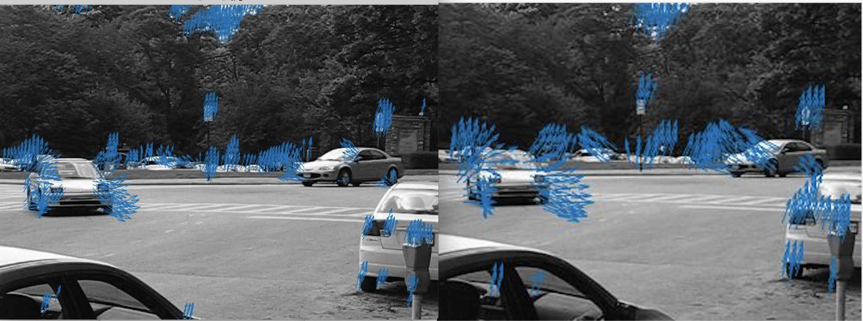

Lets look at the following parameters

K = 4, sigma = 10, region = 15.

We can also see that the background has much much less noise because movements that crossed the threshold earlier (minimum eign value) no longer cross it.

A noise that really annoyed me was at the bottom right, at the wheel of the car, or the inside of the bottom car

(I marked the noise with red)

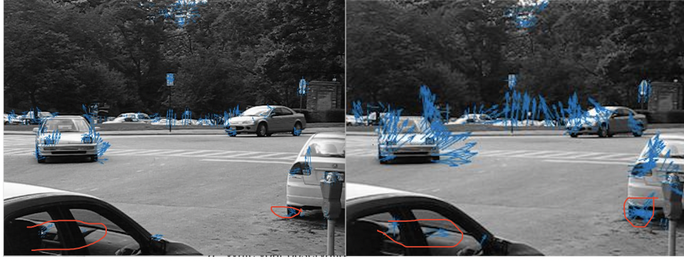

**8.b .**

The problem with the current algorithm is that globally using one size region is not enough because objects move differently, and points might not move like their neighbors, and in order to capture movements we will use windows that are too large for subtleties, or will harm our performance.

To overcome these problems we can iteratively compute the OF according to the number of times we resize it.

Let’s say we resize it 3 times.

Then we will use 1,0.5 and 0.25 as parameters for the resize function.

We have F1 and F2.

We will start with OF between F1 and F2 in scale of 0.25,

Now, larger movements were detected, we will imwarp F1 in 0.5 according to our finding in scale of 0.25. Now F1’ (the warpped image) and F2 are slightly closer than F1 and F2.

We will OF F1’ and F2 as well and use the result to warp the original size to receive F1’’. Then we use OF between F1’’, and F2. With this algorithm we can use a smaller region to capture larger movements than we would have if we just used one scale size .

ֿ

**PART B**

10. Implemented seg_OF_magnitude.

Example for result on SLIDES:

k = 10; sigma = 7; region = 15; resize_factor = 1;

th= 0.09

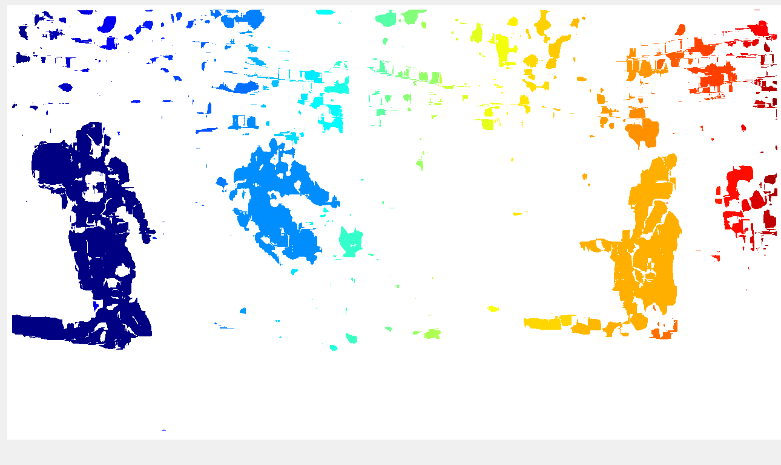

11. In class Yael warned us about using thresholds and bin because of the overlaps and limitations. Instead I will use kmeans on the angles with 4 bins (4 directions(

k = 10; sigma = 7; region = 15; resize_factor = 1;

th= 4

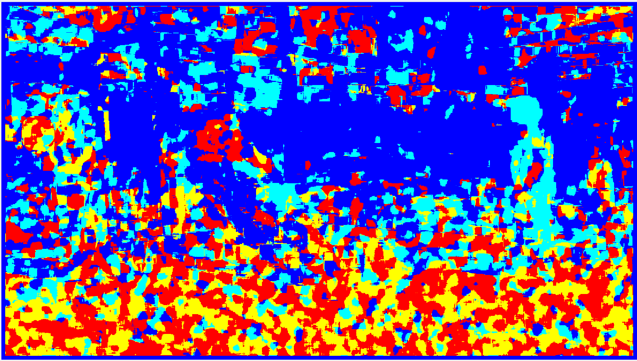

**12 - 13 I implemented change detection**

Here are some frames from the result:

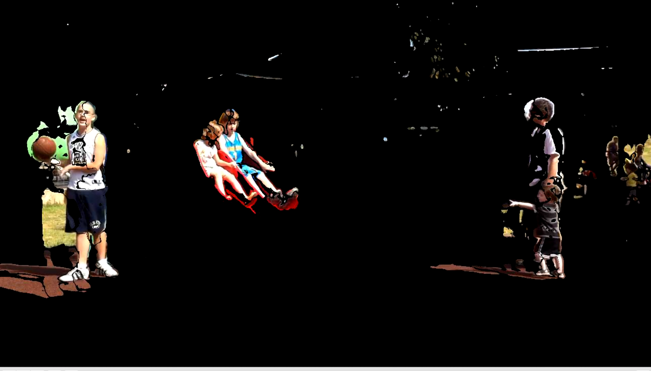

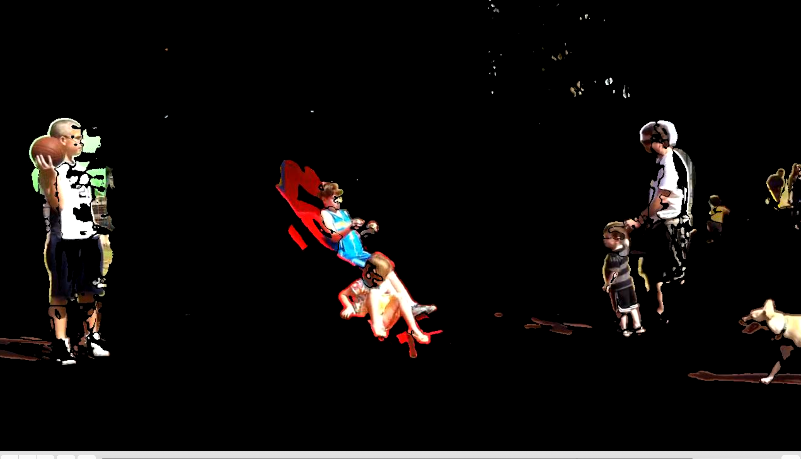

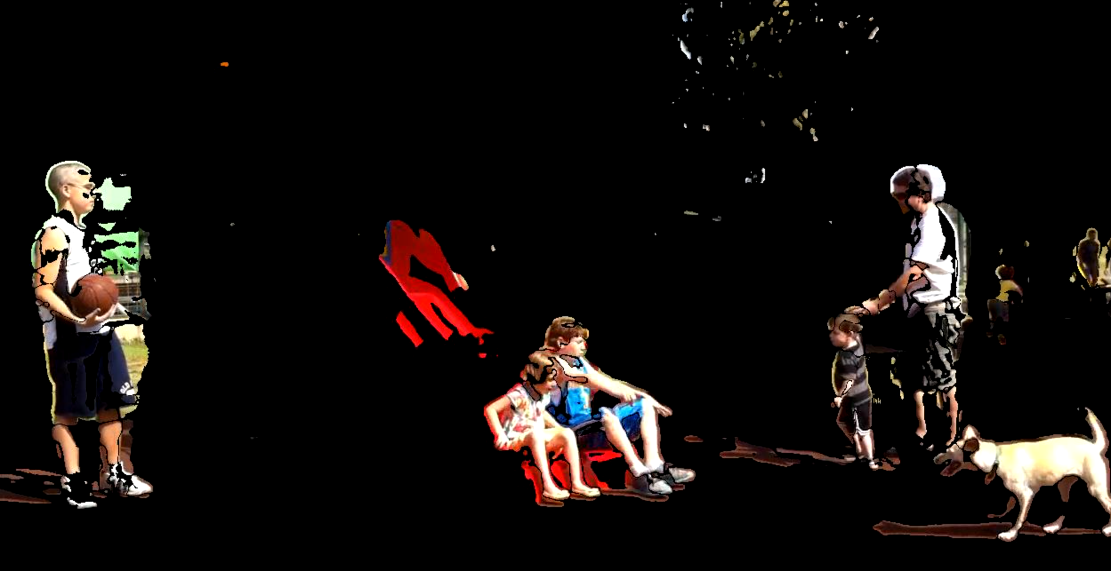

Here is a link to the result:

[slides foreground](https://drive.google.com/open?id=1DJhsq2VZrIz_bSlj186SSzE_wdp_uVte)

14. The naive change detection was extremely easy to implement and works amazingly well. The foreground is much clearer than it would have if I would get my results from the seg of orientation and try to put them in video. On the other hand it presents some limitations that I would not experience if I have used the segmentation by magnitude or segmentation by orientation. Let me discuss the pros and cons of each algorithm :

Change detection:

Pros: generally works well, easy to implement

Cons:

1. global threshold - doesn’t take into consideration that different part in the image would change differently so it would not cope with multiple modal backgrounds .
2. If you would look at the last image at the previous page you can see the top of the slide:

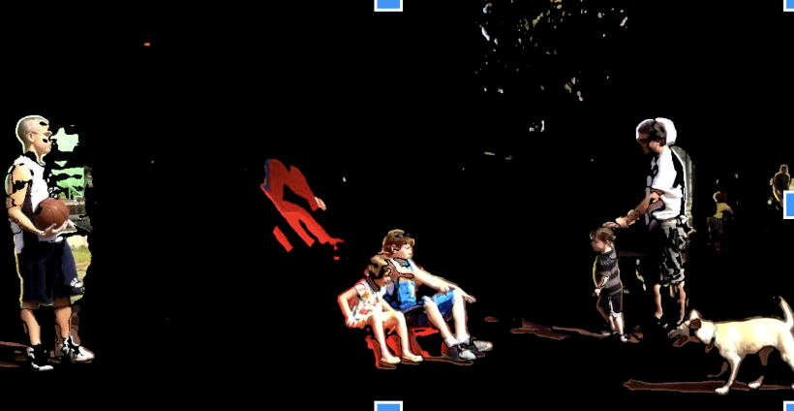

Even though it is clearly a background. The reason for that is that the majority of the video this part was hidden by the kids, so when they went down it was far enough from the threshold to appear as foreground. This is an important point because this would be definitely be detected as background by the segmentation by magnitude as you can see here:

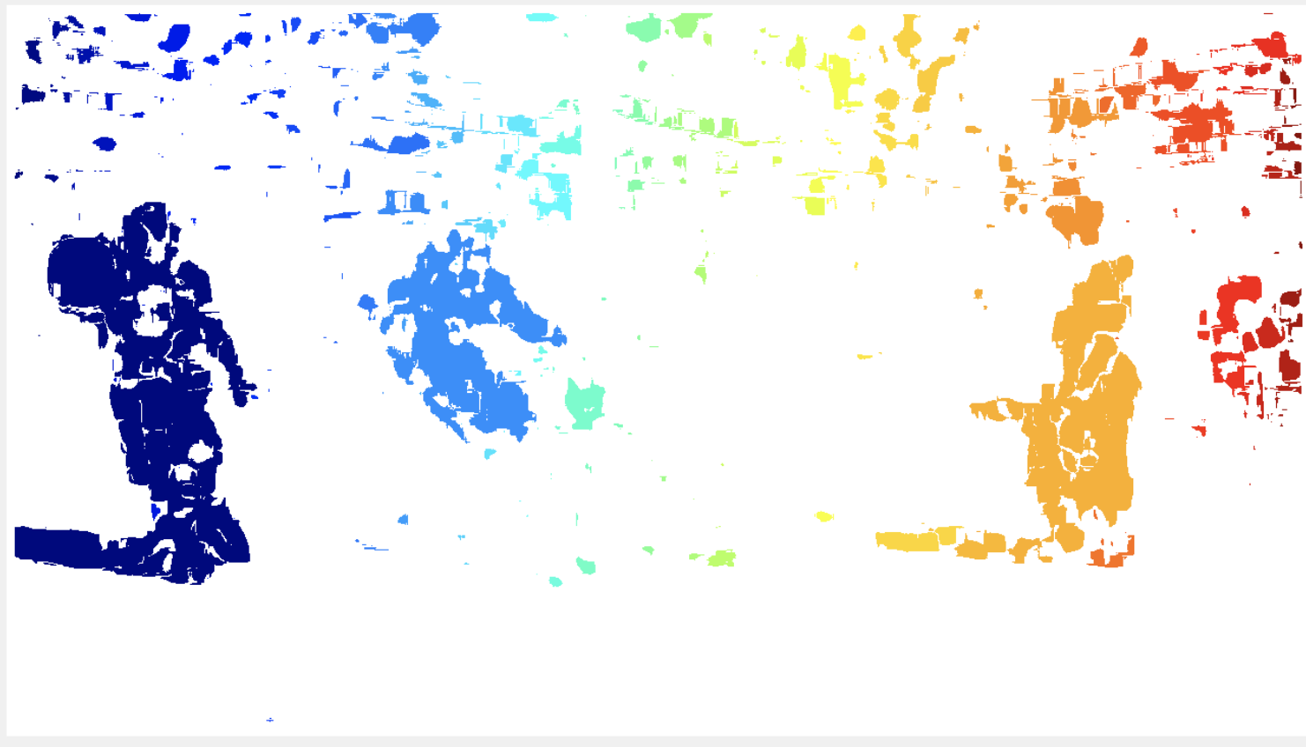

So segmentation of moving regions might work better using OF than change detection.

But the two has their limitation as well. For example by using segmentation by magnitude on an object that has both large and light movements we might not detect it as one object, in such a case we would like to consider the orientation of the movements. On the other hand when using orientation, we are not taking into consideration the coordinates on the image , so objects on different places in the image might be detected in the same way, just because their orientation is similar.

For example the father and child here were detected in similar way:

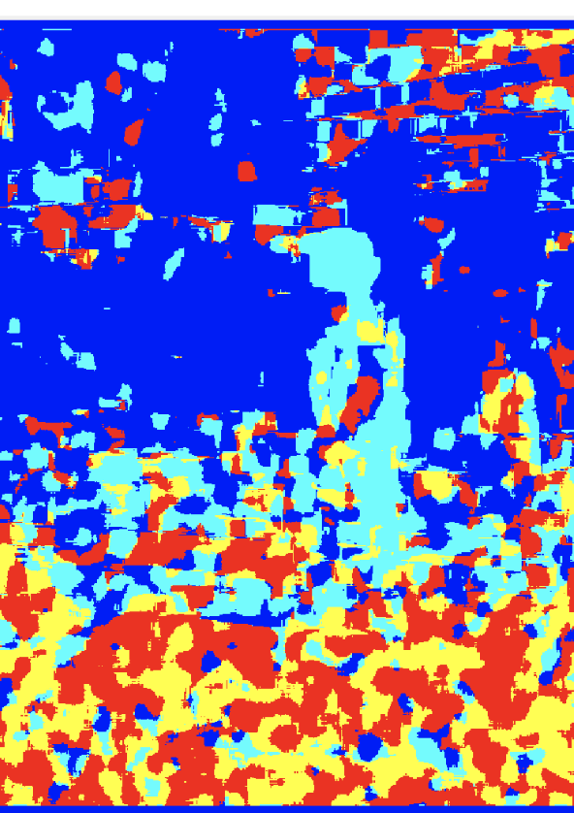

But other places in the image were detected with similar color.

So change by orientation I would definitely want to use to segment objects that are moving rigidly , like maybe tracking moving cars.

Segment by orientation would be very good to find whether a scene is changing now or not , more specifically which part of the scene is changing , without having to worry about slowly changing background and the problems it introduced to the naive change detection implementation (like the problem with the slide) .

Another big limitation on seg by OF is when the camera is moving, the background would become noisy and it would be hard to distinguish between the foreground and the background

15.

The change detection algorithm will work well only in sequences that the camera is close to static. That’s because of the basic way the algorithm works. Taking the median value of every pixels has an assumption behind it: every pixels ‘describes’ the same place in the world (x,y,z). If that spot is changing it means that something is moving there. Because of it when the camera is moving around, a single pixel will capture different points in the world and this kind of algorithm will not bring very good results. On the other hand with the right thresholding and a camera that is not to wild, we can definitely use OF based algorithms on other sequences because they are less likely to be sensitive to camera movements, but like I mentioned in 14 there are limitations to each of the algorithms .

Following is change detection by orientation and magnitude on my own sequence of moving a pen from the left to the right side of the camera

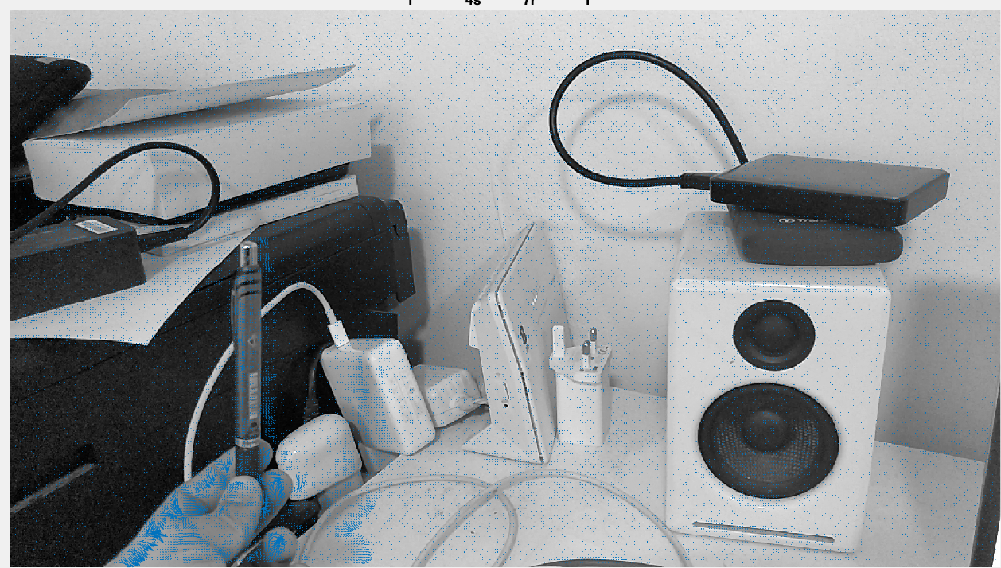

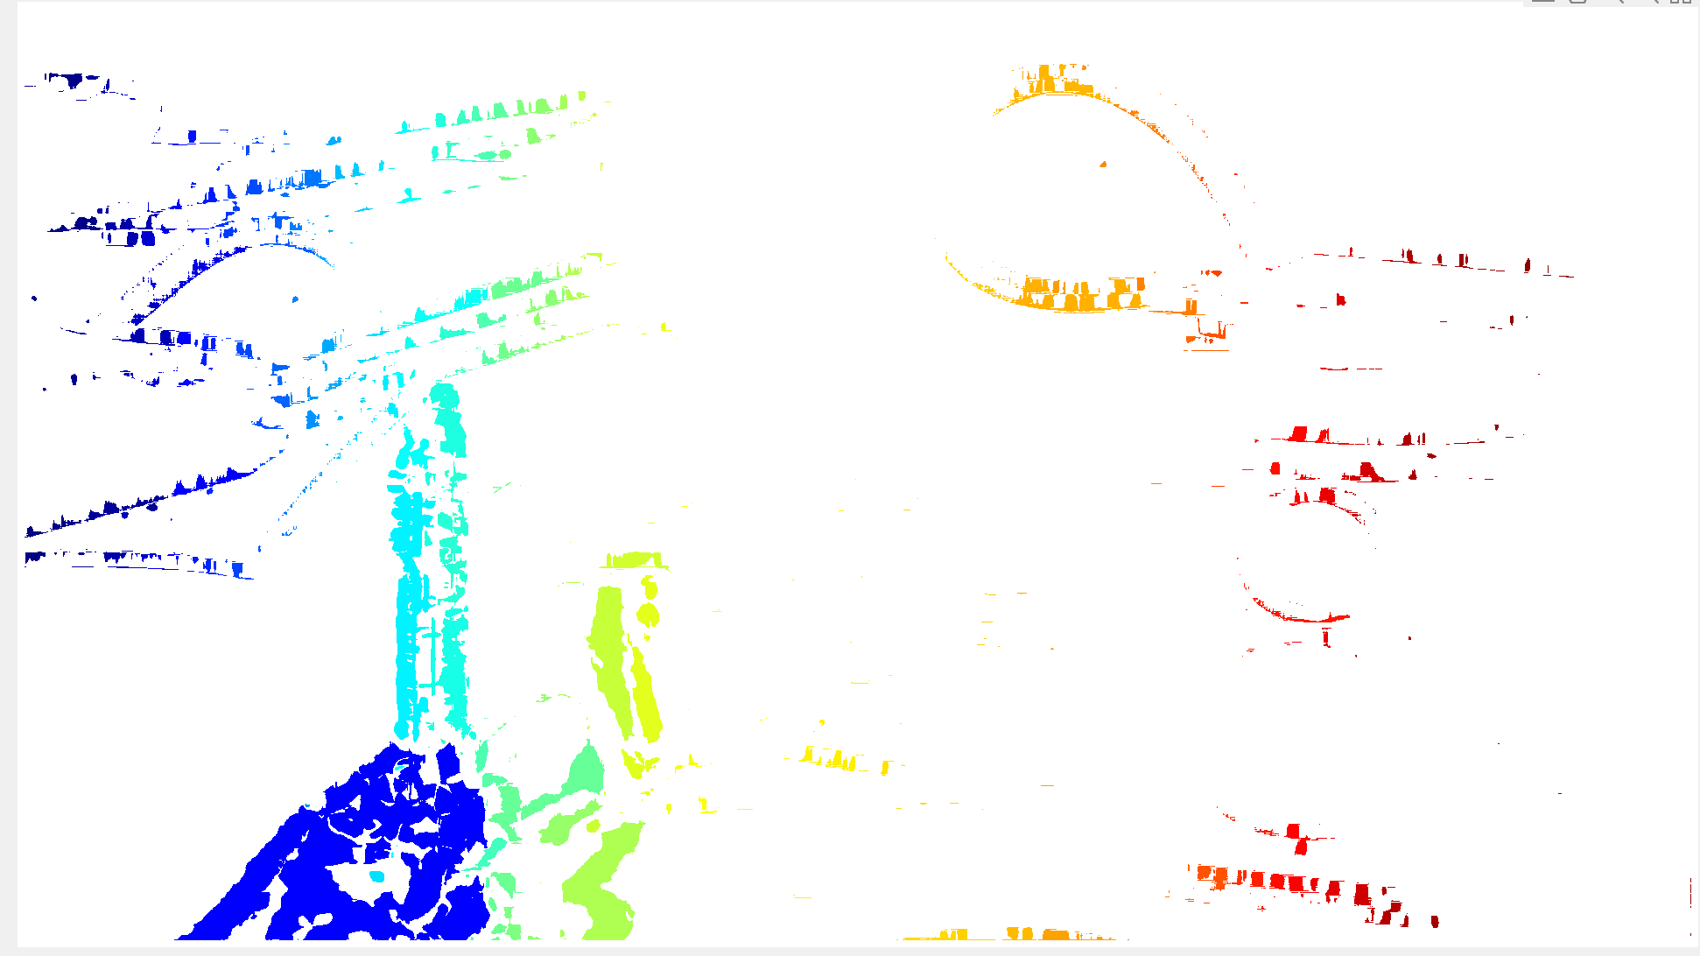

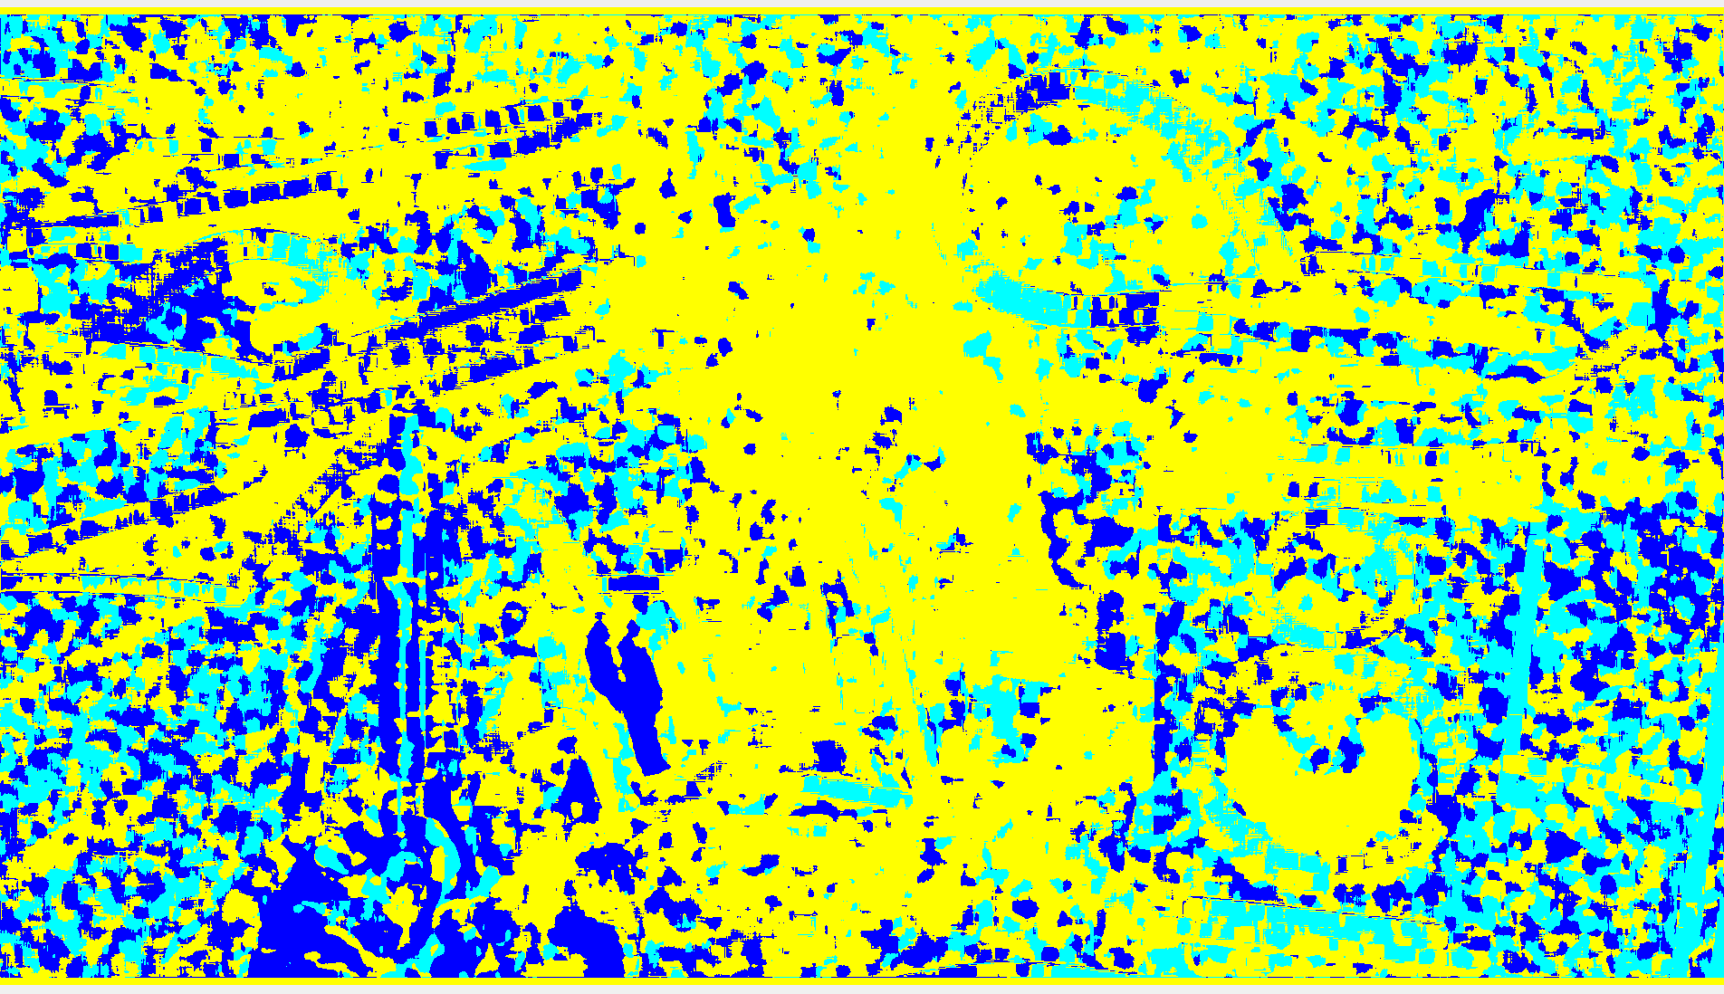

16.

For defining background based on magnitude we need that the change in background will not bigger than the change of the foreground. What this means is that if the camera is moving around, we generally need that background points (x,y,z) which is described in pixel (a,b) will not change to much in the next frame to point (a_1,b_1), at least not more than a point that describes a foreground. That way we can use use the magnitude of OF together with the right threshold to define the background.

If we want to use the orientation of optical flow to define the background and foreground some movements of the camera would now be allowed, like moving far away from the scene or closer to the scene, that way we are preserving the segmentation by orientation this algorithm is doing because all the points that are background will have a similar orientation (arrows pointing outward or pointing inward).

If we will start moving the camera in a way that points that are background will start having different orientation relative to one another, then the algorithm will fail. For example if define the camera around in a way that changes the angle all the time then the algorithm will fail for the above reason.

17.

This is not true for many reason.

Lets try an think of some:

1. If we have an object that moves towards the camera, the 3d points of that object are moving in the same direction, like a person for example the pixels that the describes the top of this had will have an upward optical flow.

Here is me moving towards the camera:

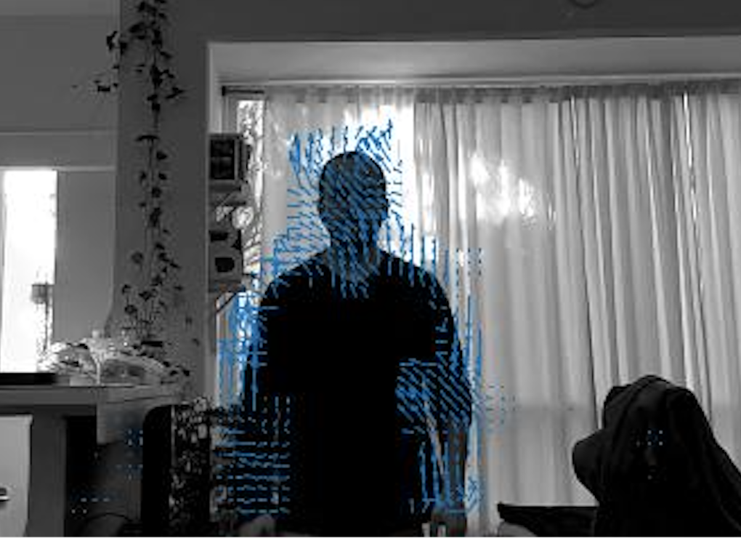

On the other hand, if there was a ball being thrown upward it would also have an optical flow upward as well. So The direction of the optical flow definitely does mean that the two objects have the same , in similar way their speed doesn't need to be the same either. The size of the optical flow, which describes the magnitude of change might be the same even though one object is far away from the camera and moves very quickly, and another object is close to the camera and moves slowly, Their optical flow size might be similar, but their real speed isn’t .

B. Objects that are far away vs. object that are close by, might have similar directions, with different speeds, but their optical flow magnitude will be the same.

Generally speaking, the world is 3 dimensions and the image is just 2, this kind of reduction has a cost of losing information. Some of the information that encodes the changes between one frame to another which is the change between point t1 to t2 in time will be lost, just like in situations that are described above.

18.

In to determine whether a scene is planar or not using the optical flow we should expect the direction of all the vectors to be the same, we should expect some smoothness between the magnitude vectors that are neighbours. We can use some threshold to determine whether it is smooth or not and we should expect that per direction in the image the magnitude will be monotonous.

19.

1. If the camera is moving in x direction, and nothing else moves in the scene then we should expect all the pixels to have optical flow in the same direction where the horizontal is vector is bigger than 0, and the vertical is close to 0.
2. Yes, regions that are closer to the camera will translate into a larger optical flow in the x direction than ones that are further away. This way we can determine which regions are closer